**CSI2006 Micro-Processor and Interfacing Techniques**

**Assignment-2**

**Aim 1 :**

To write an assembly language programming using 8086 instruction set to find the largest value from an array of given numbers.

**Aim 2 :**

To write an assembly language programming using 8086 instruction set to find the smallest value from an array of given numbers.

**Algorithm :**Input - number of array elements (count) Enter the elements to be stored in array

Process - Compare the numbers   
Conclusion – By the above process, we can find the large/small value.

**Team Members :**

Mothishwaran.C (19MID0017)  
Prashanth.S (19MID0020)  
Saksham Verma (19MID0023)  
Tharun.S (19MID0031)  
Sabarinathan R.V (19MID0057)

1)Program 🡪 Find the Largest element in an array

Code

Debug Screen

Debugging the Code

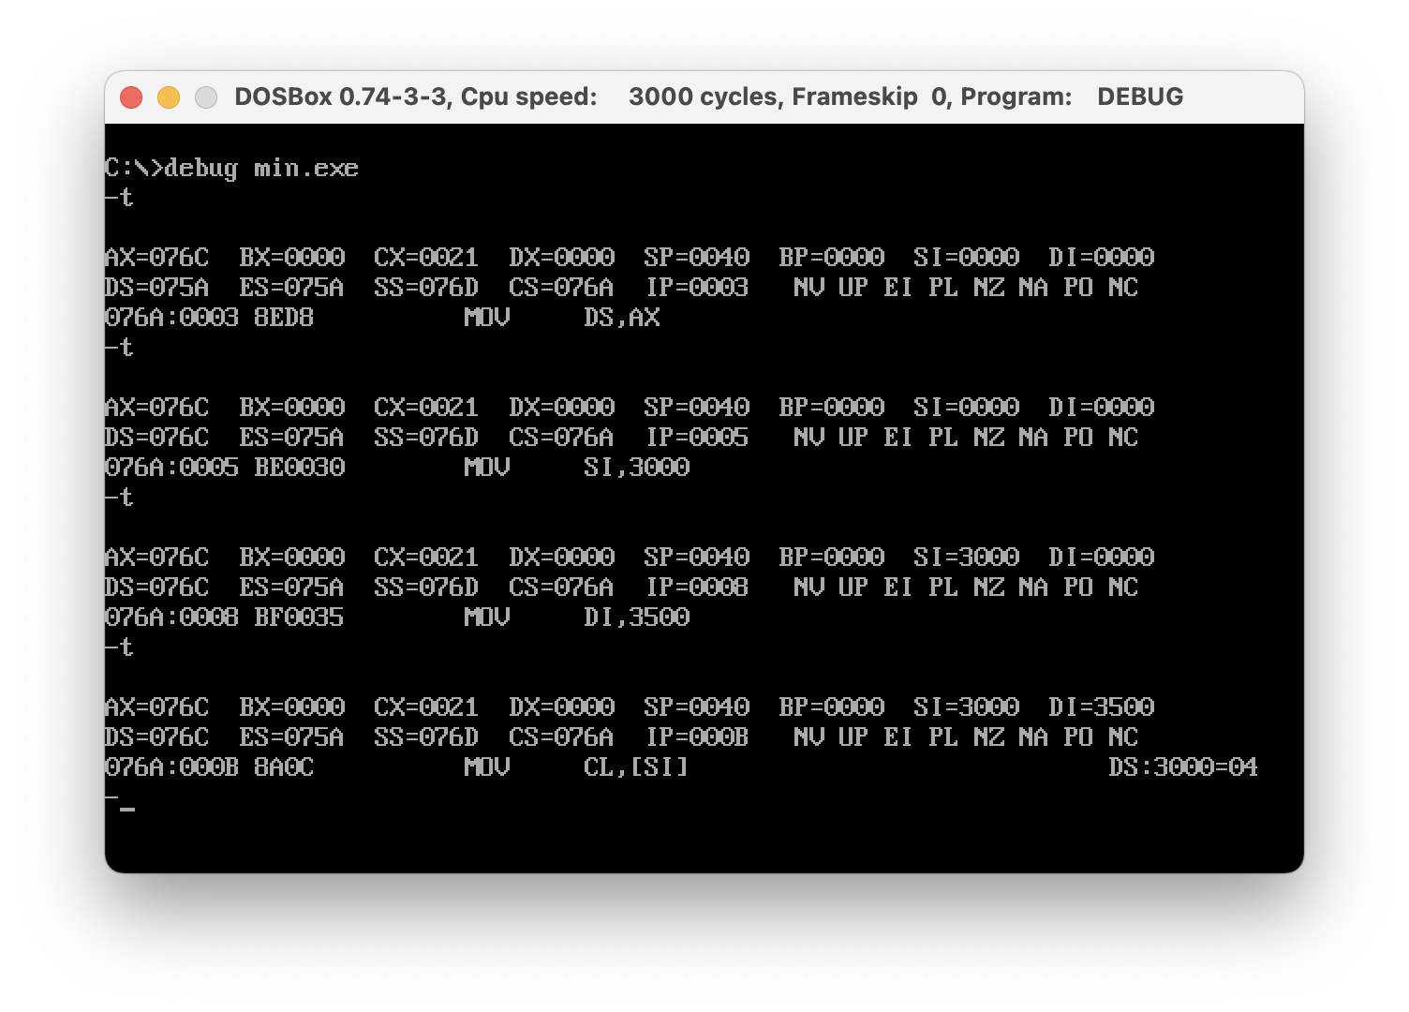

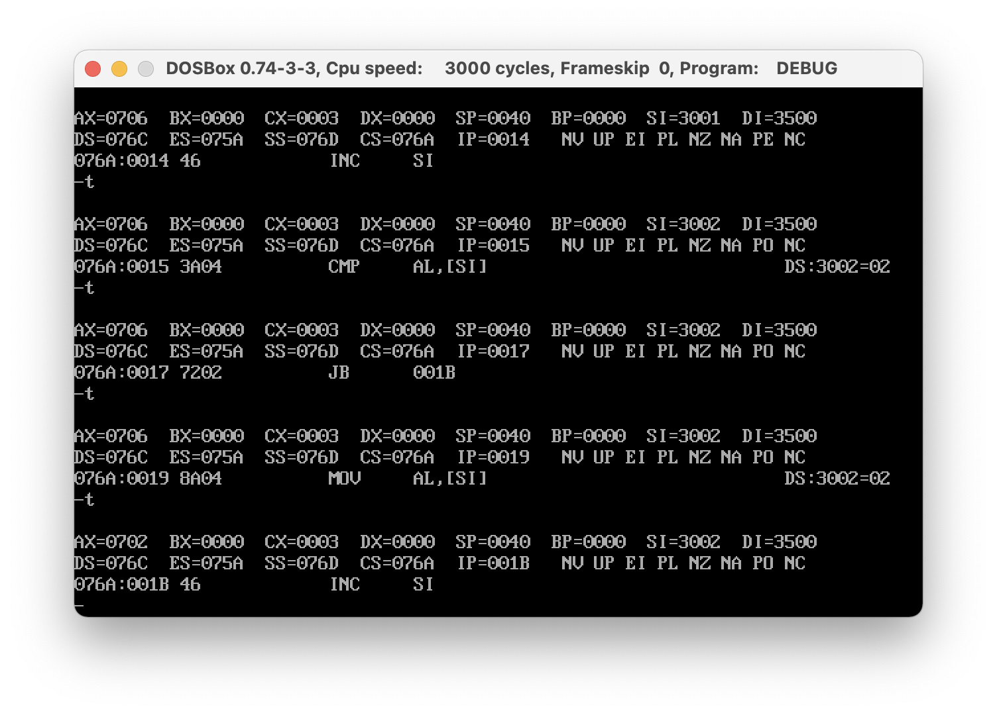

Output

2) Program 🡪 Find the Smallest element in an array

Code

Debug Screen

Output

Video Link 🡪 <https://www.youtube.com/watch?v=Gm5_NHBmGN0>